**OPS102 – Week 3 – File Systems - Sample Lab**

Student Name: Abcedi Ilacas

Student ID: 138180211

**Activity 1: File Globing**

When issuing Linux or Windows commands, it may be **more efficient** (less typing) to use **filename expansion symbols** also called **File Globing** to match files that share similar characteristics (e.g. same file extension) when issuing Linux commands.

***Example****:* You can use a special character to indicate to the Bash shell to match all files that end with the extension ".txt" in your current working directory:

**ls *.txt**  
a.txt b.txt c.txt 1.txt 2.txt 3.txt abc.txt work.txt

Below are the most common Filename Expansion symbols and how they are used for filename expansion:

|  |  |
| --- | --- |
| **Filename Expansion Symbol** | **Purpose** |
| **\*** | Asterisk (*) to represent **0 or more characters** |
| **?** | Question mark (?) to represent **exactly one character (any character)** |
| **[ ]** | Square brackets ([ ]) to represent and match for the  **character enclosed within the square brackets**. It represents ONLY ONE character - it's like a **Question Mark (?)** but with **conditions or restrictions.** |
| **[! ]** | Square brackets containing an exclamation mark immediately after the open square bracket ([! ]) to represent and match and **OPPOSITE** character for the character enclosed within the square brackets. |

Consider following file hierarchy for the activities in this section. This applies to both of Linux and Windows.

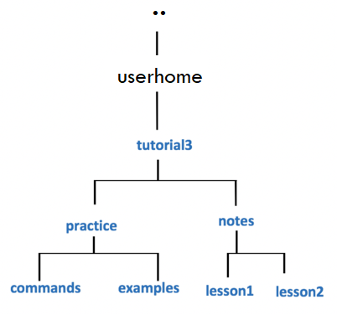

You will now get practice issuing file management commands using **filename expansion symbols**. We will be using the directory structure given above.

A great way to practice filename expansion, use the **touch** command on Linux to create a lot of empty filenames (for windows use any preferred way to create such files.), write the **ls/dir** commands that use **filename expansion**, predict the filenames that will be display, and finally run the command to check your work.

**Perform the following steps for Linux and repeat them for windows using equivalent commands learnt previously:**

1. Issue a Linux command to move to the **examples** directory  
   (i.e. under *practice* directory as shown in diagram to the right).

- cd /home/ailacas1/tutorial3/practice/examples

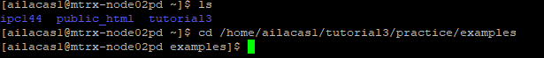

1. Issue a Linux command to confirmed that you have moved to the **examples** directory.

- pwd



1. Issue the **touch** command to create the following empty text files in the *examples* directory:  
   (note *upper* and *lowercase* letters)

**abc.txt**  
**def.text**  
**hij.TxT**  
**1a4.txt**  
**123.TXT**  
**456.txt**  
**6u9.txt**  
**ab2.html**  
**1234.txt**  
**abcdef.txt**  
**abcde.txt**

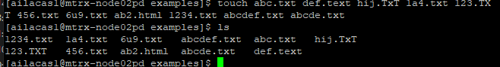

1. If you encounter errors, then make corrections (eg. **viewing directory contents**, **check for correct filename syntax**, **case sensitivity**, **missing files**, **files in the wrong location**, etc.)
2. Issue the **ls** command to get a listing of files in your *examples* directory.  
     
   The output should look identical to the diagram displayed below.  
   You can refer to this listing to see all files so you can then predict the output from Linux commands that use filename expansion symbols.

[Listing-1.png](https://wiki.cdot.senecacollege.ca/wiki/File:Listing-1.png)  


1. What do you think the output will be from the following Linux command?  
   **ls ???.txt**  
   **Write down the expected output** on paper, then **issue the command** to check your answer.

-will output all files in the directory with 3 characters and .txt file name(1a4.txt, 456.txt, 6u9.txt and abc.txt) since a ‘?’ in linux means find one character plus specifically .txt files



1. What do you think the output will be from the following Linux command?  
   **ls ?????.txt**  
   **Write down the expected output** on paper, then **issue the command** to check your answer.

-will output all files in the directory with 5 characters and .txt file name(abcde.txt) since a ‘?’ in linux means find one character plus specifically .txt files



1. What do you think the output will be from the following Linux command?  
   **ls ??????.txt**  
   **Write down the expected output** on paper, then **issue the command** to check your answer.

- will output all files in the directory with 6 characters and .txt file name(abcdef.txt) since a ‘?’ in linux means find one character plus specifically .txt files



1. What do you think the output will be from the following Linux command?  
   **ls [0-9].txt**  
   **Write down the expected output** on paper, then **issue the command** to check your answer.br>Did the command work?  
   What does this teach you about the character class [ ] symbol?

- this command will find all .txt files with one digit in the file name from 0 to 9 but in this case, we do not have a file with only one digit so it will not display such files and the command will not work

-the [ ] symbol is used for pattern matching and specifies a set of characters and the pattern will match any single character that is a member of that set



1. What do you think the output will be from the following Linux command?  
   **ls [0-9][0-9][0-9].txt**  
   **Write down the expected output** on paper, then **issue the command** to check your answer.

-will display .txt files that has 3 digits in the file name such as file 456.txt and will not display file 123.TXT since it is a TXT file



1. What do you think the output will be from the following Linux command?  
   **ls [a-z][a-z][a-z].txt**  
   **Write down the expected output** on paper, then **issue the command** to check your answer.

-will display .txt files that has 3 lowercase letters in the file name such as file abc.txt



1. What do you think the output will be from the following Linux command (using character class with UPPERCASE letters)?:  
   **ls [A-Z][A-Z][A-Z].txt**  
   **Write down the expected output** on paper, then **issue the command** to check your answer.

-will display .txt files that has 3 uppercase letters in the file name but we don’t have any files with uppercase letters so it will not display any files



-displayed lowercase files instead

1. What do you think the output will be from the following Linux command (using character class using alpha-numeric characters)?  
   **ls [a-zA-Z0-9][a-zA-Z0-9][a-zA-Z0-9].txt**  
   **Write down the expected output** on paper, then **issue the command** to check your answer.

-will display all files that contain any three alphanumeric characters and that has a .txt extension



1. What do you think the output will be from the following Linux command?  
   **ls *.txt**  
   **Write down the expected output** on paper, then **issue the command** to check your answer. Did ALL text files get listed? Why not?

-will display files that have .txt extension and only the specified .txt file



1. What do you think the output will be from the following Linux command?  
   **ls *.[tT][xX][tT]**  
   **Write down the expected output** on paper, then **issue the command** to check your answer. Did ALL text files get listed this time? If so, why?

-this command will list files with .txt .TxT . TXT and all uppercase lowercase variations of .txt



1. **NOTE:** We have just been using filename expansion symbols just with the ls command.  
   Filename expansion symbols can be used for ANY Linux file management command (e.g. **cat**, **more**, **less**, **cp**, **mv**, **rm**, **ls**, etc.).  
     
   Let's get some practice issuing these other Linux file management commands.
2. Issue the following Linux command: **file *.[tT][xX][tT]**  
   What is the purpose of this command? Which files are contained in this output?

-this command displays the file type of all files with a .txt or any similar extension and will display what type of data it hass like ASCII text or if its empty

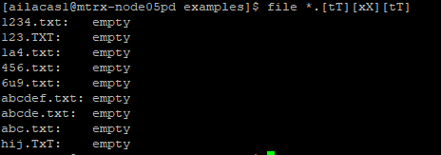

1. Change to the **commands** directory using an **absolute** pathname  
   (use the diagram on right-side for reference).



1. Issue a Linux command to confirm that you are now in the **commands** directory.



1. Issue the following Linux command (lowercase "l" NOT the number "1"):  
   **cp /bin/l*   .**  
   View the contents of the contents directory. What did this command do?

-this command will copy all files beginning with “l” in the /bin directory into the current directory

1. Issue the following Linux command: **rm \***  
     
   View the contents of the contents directory. What did this command do?

-this command will delete all files in the current directory



1. Issue the following Linux command (lowercase "l" NOT the number "1"):  
   **cp /bin/l?   .**  
   View the contents of the contents directory. What did this command do?

-this command copies all files from the /bin directory that start with the letter l and also have exactly one more character in their name in the current directory



1. Issue the following Linux command: **rm l[!s]**  
   View the contents of the contents directory. What did this command do?

-will delete all files in the current directory that start with the letter l and not following an s



1. Use a text editor (nano or vi) to create the file called **ab** in the **commands** directory that contains the line of text below,  
   and then save editing changes to this file:  
   This is file ab



1. Use a text editor (nano or vi) to create the file called **cd** in the **commands** directory that contains the line of text below,  
   and then save editing changes to this file:  
   This is file cd



1. Use a text editor (nano or vi) to create the file called **ef** in the **commands** directory that contains the line of text below,  
   and then save editing changes to this file:  
   This is file ef



1. Issue the following Linux command: **cat ??**  
     
   View the contents of the contents directory. What did this command do? Why does the output look strange?  
     
   **NOTE:** Press the keys **ctrl-c** to return to the shell prompt.

-this command will display the contents of files with 2 characters in the file name

-cat command is used to read, concatenate, and display the contents of files to the standard output

-the cat command will display the binary data as text which will look strange

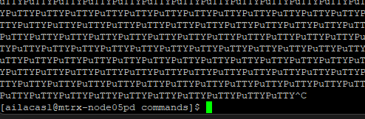

1. Issue the following Linux command: **cat [!l][!s]**  
     
   View the contents of the contents directory. What did this command do? Does the output look better? If so, why?

-this command will display the contents of files that do not start with l and are not followed by an s

-it displays a better output of the data inside the files

-this command was more specific to only open the files we just made but cat ?? opened the binary file which displayed weird characters

